**Project NCHRP 22-49: The Effect of Vehicle Mix on Crash Frequency and Crash Severity**

**Spreadsheet Tool User’s Guide**

Prepared for NCHRP

Transportation Research Board

of

The National Academies of Sciences, Engineering, and Medicine

**TRANSPORTATION RESEARCH BOARD**

**OF THE NATIONAL ACADEMIES**

**PRIVILEGED USE DOCUMENT**

This document, not released for publication, is furnished only for

review to members of or participants in the work of CRP. This

document is to be regarded as fully privileged and dissemination

of the information included herein must be approved by CRP.

**Report Prepared by**

Naveen Eluru, Tanmoy Bhowmik, Shahrior Pervaz, Dewan Ashraful Parvez,

Lauren Hoover, Mohamed Abdel-Aty, John N. Ivan, Kai Wang, Shanshan Zhao

**University of Central Florida, Orlando, FL**

**University of Connecticut, Storrs Mansfield, CT**

**June 2023**

Permission to use any unoriginal material has been

obtained from all copyright holders as needed.

**TABLE OF CONTENTS**

LIST OF TABLES iii

LIST OF FIGURES iv

1 PROJECT BACKGROUND 1

1.1 Development of the Statistical Models 1

1.2 Development of the Excel Spreadsheet Tools 3

2 22-49 SPREADSHEET TOOL WITHOUT CALIBRATION 5

2.1 Opening the Tool 5

2.2 Import Data 6

2.3 Selection of Facility 11

2.4 Estimation of Prediction 14

3 22-49 SPREADSHEET TOOL WITH CALIBRATION 18

3.1 Opening the Tool 18

3.2 Import Data 18

3.3 Selection of Facility 21

3.4 Estimation of Prediction 22

3.5 Calibration 24

3.6 Development of Cure Plot 26

4 22-49 DATA INPUT AND PREDICTION TOOL 28

4.1 Opening the Tool 28

4.2 Segment Data Input and Prediction 28

4.3 Intersection Data Input and Prediction 33

# LIST OF TABLES

Table 1.1 Description of the Facilities 2

Table 1.2 Recommended Model for Each Facility 3

Table 2.1 Description of the Variables 7

# LIST OF FIGURES

Figure 2.1 Unblocking the Tool 5

Figure 2.2 Enabling the Content 6

Figure 2.3 Data Import (Spreadsheet Tool without Calibration) 8

Figure 2.4 Workbook for RA4LUD with “data” Tab (Spreadsheet Tool without Calibration) 9

Figure 2.5 Variable List View (Spreadsheet Tool without Calibration) 10

Figure 2.6 ImportedData Tab (Spreadsheet Tool without Calibration) 11

Figure 2.7 Facility Selection (Spreadsheet Tool without Calibration) 12

Figure 2.8 Facility Description (Spreadsheet Tool without Calibration) 13

Figure 2.9 Defined SPF Tab (Spreadsheet Tool without Calibration) 14

Figure 2.10 Estimating Prediction (Spreadsheet Tool without Calibration) 15

Figure 2.11 Options to Use User-Defined Calibration Factors (Spreadsheet Tool without Calibration) 16

Figure 2.12 Estimated Prediction Results of RA4LUD Facility (Spreadsheet Tool without Calibration) 17

Figure 3.1 Data Import (Spreadsheet Tool with Calibration) 18

Figure 3.2 Workbook for RA4LUD Facility with “data” Tab (Spreadsheet Tool with Calibration) 19

Figure 3.3 Variable List (Spreadsheet Tool with Calibration) 20

Figure 3.4 ImportedData Tab (Spreadsheet Tool with Calibration) 20

Figure 3.5 Facility Selection (Spreadsheet Tool with Calibration) 21

Figure 3.6 Facility Description (Spreadsheet Tool with Calibration) 22

Figure 3.7 Defined SPF Tab (Spreadsheet Tool with Calibration) 22

Figure 3.8 Selection of Output (Spreadsheet Tool with Calibration) 23

Figure 3.9 Estimated Prediction Results of RA4LUD Facility (Spreadsheet Tool with Calibration) 23

Figure 3.10 Estimated Calibrated Prediction Results of RA4LUD Facility 25

Figure 3.11 Calibration Factors for RA4LUD Facility 25

Figure 3.12 Cure Plots Tab 26

Figure 3.13 Residuals and Confidence Limits of the Cure Plots for RA4LUD Facility 27

Figure 4.1 “Segment Input” Tab 29

Figure 4.2 Selection of Segment Facility Type 29

Figure 4.3 Generating Segment Dataset and Prediction 30

Figure 4.4 Segment Data Input Error 31

Figure 4.5 “Segment Output” Tab Showing Input Data 31

Figure 4.6 “Segment Output” Tab Showing Predictions 32

Figure 4.7 Clearing the Segment Output 33

Figure 4.8 “Intersection Input” Tab 34

Figure 4.9 Selection of Intersection Facility Type 34

Figure 4.10 Generating Intersection Dataset and Prediction 35

Figure 4.11 Intersection Data Input Error 35

Figure 4.12 “Intersection Output” Tab Showing Data 36

Figure 4.13 “Intersection Output” Tab Showing Predictions 36

Figure 4.14 Clearing the Intersection Input Data 37

# PROJECT BACKGROUND

The first edition of the Highway Safety Manual (HSM) has provided methods and procedures in estimating total crashes, crashes by type and crashes by severity at the site-level, project-level and corridor level. The development of HSM in 2010 provided a compendium of practically deployable quantitative safety methods for adoption by practitioners at various agencies including states, counties, and metropolitan planning organizations. Broadly, the quantitative model components can be classified as safety performance functions (SPFs), severity distribution functions (SDFs), SPF adjustment factors (AFs), and crash modification factors (CMFs). These four model components currently do not accommodate the influence of vehicle mix, a factor shown to be valuable for explaining both crash frequency and severity. Recent research efforts have shown that heavy vehicle traffic and vehicle mix have a substantial impact on crash frequency and severity. These studies indicate that the consideration of vehicle mix would improve predictive methods for crash frequency and severity. Improved methods will result in better use of the limited funds and resources available for improving the safety of the highway system and support performance-based approaches. To examine how vehicle mix data can influence the model infrastructure in HSM, this project titled “The Effect of Vehicle Mix on Crash Frequency and Crash Severity, NCHRP 22-49” sets following objectives:

* *Develop and validate a statistically valid predictive methodology to quantify the effect of vehicle mix on crash frequency and severity for various facility types, and*
* *Develop a spreadsheet tool for practitioners to quantify the effect of vehicle mix on safety performance across the range of highway activities including planning, design, operations, and safety management.*

## Development of the Statistical Models

For incorporating vehicle mix into the prediction of crash frequency and severity, the research team incorporated three approaches including: 1) the HSM model framework, (2) use of multivariate model estimation methods to develop separate frequency models by crash severity level, and (3) the negative binomial-fractional split method to predict crash frequency by severity. Based on the model performance and several predictive measures, the project selected the preferred model to estimate crash frequency and severity for different segment and intersection facilities. The following sections provide an overview of the study facility types and preferred models for these facilities.

### Facility selection

The facilities considered for the model development in the current project include:

* Roadway Facility
  + Urban Limited Access Facilities
  + Rural Limited Access Facilities
  + Urban Arterials
  + Rural Arterials
* Intersection Facility
  + Urban Intersections
  + Rural Intersections

The above roadway and intersection facilities were divided into several sub-facilities based on the number of lanes, presence of divider and types of traffic control system. The sub-facilities are listed in Table 1.1.

**Table 1.1 Description of the Facilities**

|  |  |  |
| --- | --- | --- |
| **Facility Location** | **Facility Group** | **Facility** |
| Roadway Facility | Urban Limited Access | Urban 4-lane divided (ULA4LD) |
| Urban 6-lane divided (ULA6LD) |
| Urban 8-lane divided (ULA8LD) |
| Urban 10-lane divided (ULA10LD) |
| Rural Limited Access | Rural 4-lane divided (RLA4LD) |
| Rural 6-lane divided (RLA6LD) |
| Rural 8-lane divided (RLA8LD) |
| Urban Arterials | Urban 2-lane undivided (UA2LUD) |
| Urban 3-lane (UA3L) |
| Urban 5-lane (UA5L) |
| Urban 4-lane undivided (UA4LUD) |
| Urban 4-lane divided (UA4LD) |
| Rural Arterials | Rural 2-lane undivided (RA2LUD) |
| Rural 3-lane (RA3L) |
| Rural 5-lane (RA5L) |
| Rural 4-lane undivided (RA4LUD) |
| Rural 4-lane divided (RA4LD) |
| Intersection Facility | Urban Intersections | Urban 3-leg STOP controlled (U3ST) |
| Urban 4-leg STOP controlled (U4ST) |
| Urban 3-leg signalized (U3SG) |
| Urban 4-leg signalized (U4SG) |
| Rural Intersections | Rural 3-leg STOP controlled (R3ST) |
| Rural 4-leg STOP controlled (R4ST) |
| Rural 4-leg signalized (R4SG) |

### Preferred models

Based on the model performance and several predictive measures, the project describes the preferred models to estimate crash frequency and severity. The final preferred model systems for the facilities identified are presented in Table 1.2.

**Table 1.2 Preferred Model for Each Facility**

|  |  |  |
| --- | --- | --- |
| **Facility Group** | **Facility** | **Preferred Models** |
| Urban Limited Access | Urban 4-lane divided (ULA4LD) | NB-OPFS |
| Urban 6-lane divided (ULA6LD) | HSM |
| Urban 8-lane divided (ULA8LD) |
| Urban 10-lane divided (ULA10LD) |
| Rural Limited Access | Rural 4-lane divided (RLA4LD) | HSM |
| Rural 6-lane divided (RLA6LD) |
| Rural 8-lane divided (RLA8LD) |
| Urban Arterials | Urban 2-lane undivided (UA2LUD) | NB-OPFS |
| Urban 3-lane (UA3L) |
| Urban 5-lane (UA5L) |
| Urban 4-lane undivided (UA4LUD) |
| Urban 4-lane divided (UA4LD) |
| Rural Arterials | Rural 2-lane undivided (RA2LUD) | NB-OPFS |
| Rural 3-lane (RA3L) |
| Rural 5-lane (RA5L) |
| Rural 4-lane undivided (RA4LUD) |
| Rural 4-lane divided (RA4LD) |
| Urban Intersections | Urban 3-leg STOP controlled (U3ST) | MVPLN |
| Urban 4-leg STOP controlled (U4ST) |
| Urban 3-leg signalized (U3SG) |
| Urban 4-leg signalized (U4SG) |
| Rural Intersections | Rural 3-leg STOP controlled (R3ST) | NB-OPFS |
| Rural 4-leg STOP controlled (R4ST) |
| Rural 4-leg signalized (R4SG) |

## Development of the Excel Spreadsheet Tools

To aid the practitioners in implementing the new models the research team developed three excel spreadsheet tools including:

a) 22-49 Spreadsheet Tool without Calibration,

b) 22-49 Spreadsheet Tool with Calibration, and

b) 22-49 Data Input and Prediction Tool

The first tool - Spreadsheet Tool without Calibration – provides crash frequency and severity predictions for the user provided data directly without considering calibration or using user-defined calibration factors.

The second tool - Spreadsheet Tool with Calibration – provides crash frequency and severity predictions for the user provided data while modifying the predictions considering calibration.

The third tool - Data Input and Prediction Tool – provides the practitioners a tool to undertake crash frequency and severity analysis at a facility resolution (i.e., a specific segment or intersection).

The tools allow the user to upload their jurisdiction data and generate predictions with or without calibration, provide calibration factors and generate graphs for validating the results. This document provides detailed instructions on how to use the three developed tools. The second Chapter of this document provides guidance for 22-49 Spreadsheet Tool without Calibration while guidance to use 22-49 Spreadsheet Tool with Calibration is provided in the third Chapter. In Chapter 4, suggestions for 22-49 Data Input and Prediction Tool are described.

# 22-49 SPREADSHEET TOOL WITHOUT CALIBRATION

The excel spreadsheet tool “22_49 Spreadsheet Tool without Calibration” developed in this project offers the users an interface to generate crash predictions for different facilities based on the safety performance functions developed in this project. The tool allows practitioners to import the data for the desired facilities (segments and intersections) and obtain crash predictions for the facility. Detailed guidance to use the tool is presented in the next sections.

## Opening the Tool

The users can simply open “22_49 Spreadsheet Tool without Calibration” as any other excel file for analysis. However, sometimes, the computer may provide some warning/error messages. In that case, to use the tool, the users need to unblock the tool for first-time use. For unblocking, the users need to right click on the “22_49 Spreadsheet Tool without Calibration” and in the properties option, the unblock option has to be checked and applied (as shown in Figure 2.1).

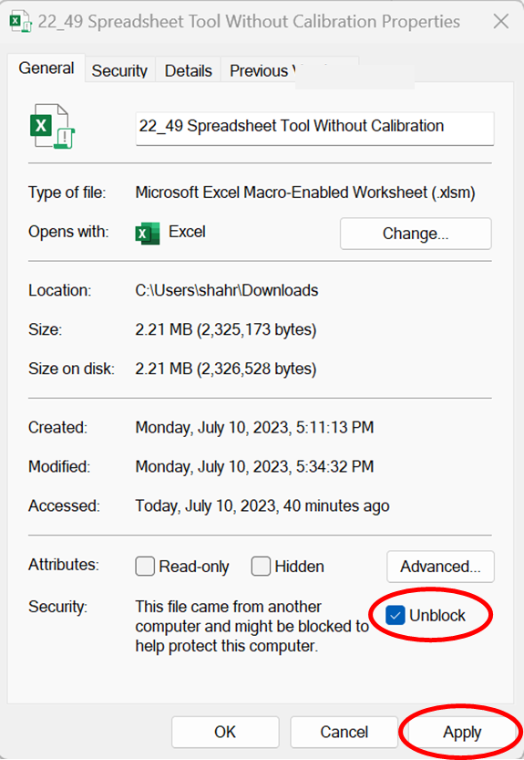

**Figure 2.1 Unblocking the Tool**

After unblocking and opening the tool, the users might need to "Enable Content” to use the tool for analysis (Figure 2.2).

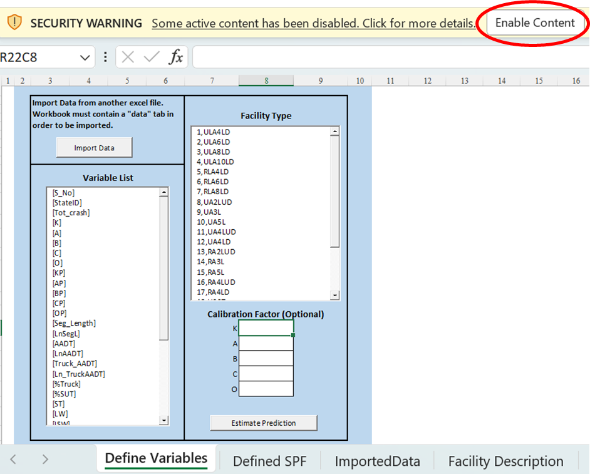

**Figure 2.2 Enabling the Content**

After enabling the content, the users should be able to use the tool. The tool has four tabs: Define Variables, Defined SPF, Imported Data and Facility Description. In the next section, we will demonstrate the use of the tabs with an example dataset of Rural arterial 4-lane undivided (RA4LUD) segments facility.

## Import Data

The users need to import data from another excel file for the analysis of a facility by using “Import Data” from the “Define Variables” tab of the tool (Figure 2.3).

### Preparation of input workbook

The users first need to prepare an input excel workbook file that must contain a “data" tab in order to be imported in the tool. The workbook should contain the information of observed crash counts and all the relevant information of independent variables. The users should note that the names of the variables should be exactly the same as the names used in this tool. If the users import dataset with different variable names, the tool might show “Application-defined or object-defined error”. The description of the variables used in the tools is presented in Table 2.1.

**Table 2.1 Description of the Variables**

| **Variable Names** | **Description** |
| --- | --- |
| *Dependent Variables* | |
| Tot_crash | Total crash count |
| K | Fatal injury crash count |
| A | Incapacitating injury crash count |
| B | Non-incapacitating injury crash count |
| C | Possible injury crash count |
| O | No injury/PDO crash count |
| KP | Proportion of fatal injury crash count |
| AP | Proportion of incapacitating injury crash count |
| BP | Proportion of non-incapacitating injury crash count |
| CP | Proportion of possible injury crash count |
| OP | Proportion of no injury crash count |
| *Independent Variables for Segment Facilities* | |
| AADT | Annual Average Daily Traffic |
| LnAADT | Ln (Annual Average Daily Traffic) |
| Truck_AADT | Annual Average Daily Truck Traffic |
| Ln_TruckAADT | Ln (Annual Average Daily Truck Traffic) |
| %Truck | % Total truck traffic in AADT |
| %SUT | % Single unit truck traffic in AADT |
| HTZ | This value is set to 1, if the segment is located at high truck zone and 0 otherwise |
| Seg_Length | Length of the segment, miles |
| LnSegL | Ln (Length of the segment, miles) |
| LW | Lane width, ft |
| OSW | Outside/Right shoulder width, ft |
| ISW | Inside/Left shoulder width, ft |
| ST | Shoulder type (paved or unpaved) |
| MW | Median width, ft |
| SL | Speed limit, mph |
| Year | Number of years |
| Ln_Year | Ln (Number of years) |
| St_CA | This value is set to 1, if the segment is from California state and 0 otherwise |
| St_CT | This value is set to 1, if the segment is from Connecticut state and 0 otherwise |
| St_FL | This value is set to 1, if the segment is from Florida state and 0 otherwise |
| St_IL | This value is set to 1, if the segment is from Illinois state and 0 otherwise |
| St_MN | This value is set to 1, if the segment is from Minnesota state and 0 otherwise |
| St_TX | This value is set to 1, if the segment is from Texas state and 0 otherwise |
| St_WA | This value is set to 1, if the segment is from Washington state and 0 otherwise |
| *Independent Variables for Intersection Facilities* | |
| MajAADT | Major road AADT |
| MinAADT | Minor road AADT |
| Ln(MajAADT) | Ln (Major road AADT) |
| Ln(MinAADT) | Ln (Minor road AADT) |
| MajTruckAADT | Major road truck AADT |
| MinTruckAADT | Minor road truck AADT |
| %MajTruck | % Truck traffic in major road AADT |
| %MinTruck | % Truck traffic in minor road AADT |
| HTZ | This value is set to 1, if the intersection is located at high truck zone and 0 otherwise |
| MajLane | Number of lanes in major road |
| MinLane | Number of lanes in minor road |
| Light | Presence of light |
| MajSL | Major road speed limit, mph |
| Year | Number of years |
| Ln_Year | Ln (Number of years) |
| St_CA | This value is set to 1, if the segment is from California state and 0 otherwise |
| St_CT | This value is set to 1, if the segment is from Connecticut state and 0 otherwise |
| St_FL | This value is set to 1, if the segment is from Florida state and 0 otherwise |
| St_MN | This value is set to 1, if the segment is from Minnesota state and 0 otherwise |

For the demonstration purpose, we import the dataset of RA4LUD facility (Figure 2.4).

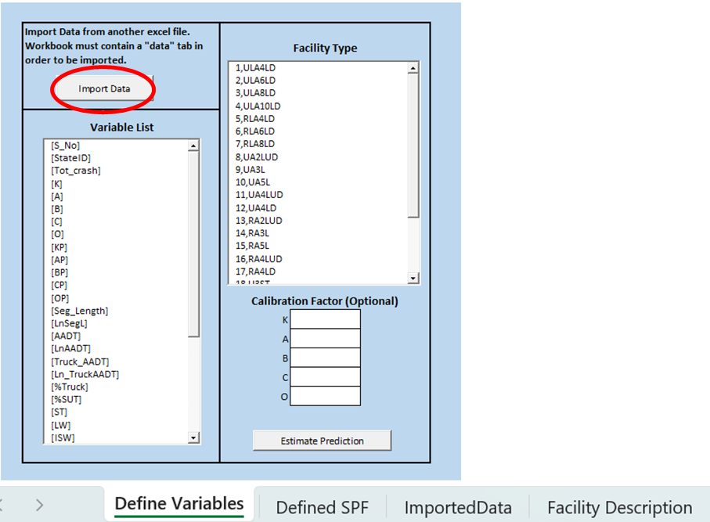

**Figure 2.3 Data Import (Spreadsheet Tool without Calibration)**

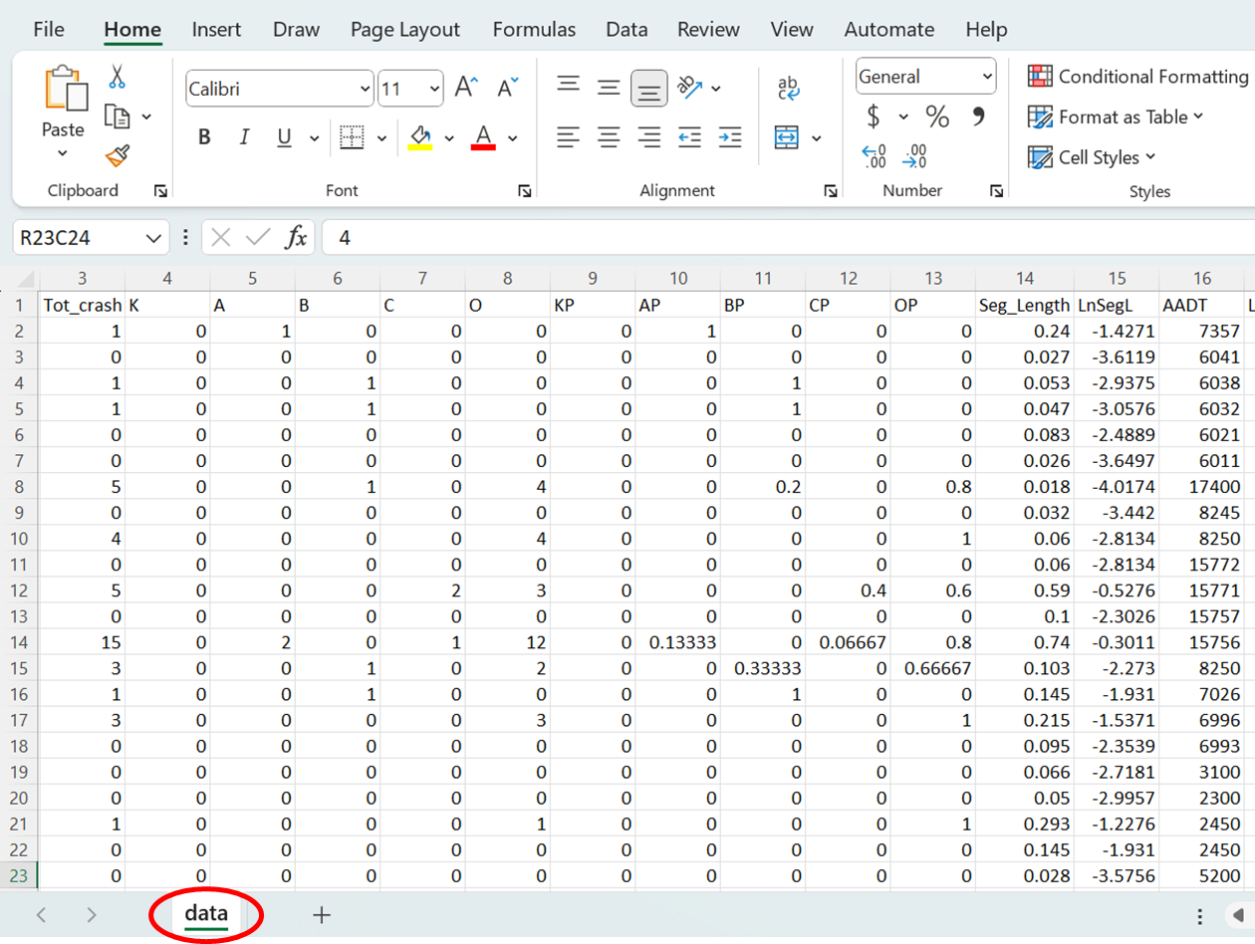

**Figure 2.4 Workbook for RA4LUD with “data” Tab (Spreadsheet Tool without Calibration)**

After importing the data successfully, the users will be able to see the variable names in the “Variable List” view of the “Define Variables” tab (Figure 2.5) and the data in the “ImportedData” tab of the tool (Figure 2.6).

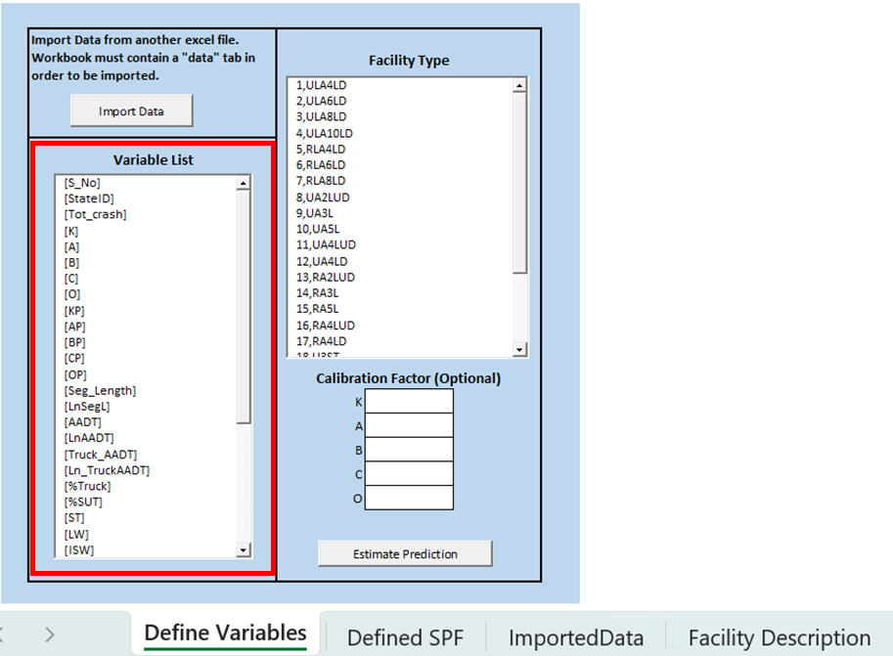

**Figure 2.5 Variable List View (Spreadsheet Tool without Calibration)**

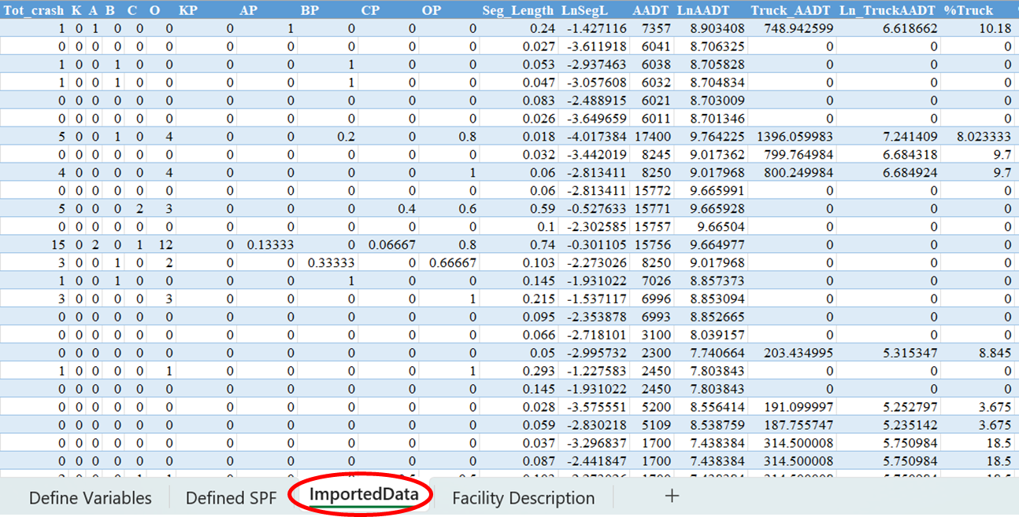

**Figure 2.6 ImportedData Tab (Spreadsheet Tool without Calibration)**

## Selection of Facility

The “Facility Type” view in the “Define Variables” tab shows the list of facilities for which SPFs have been developed in this project (Figure 2.7). The users will need to select the facility type (for this example, RA4LUD) from this list. The users should note that the full forms of the facility names can be found in the “Facility Description” Tab (Figure 2.8). This project developed SPFs for a total of 24 facilities. The SPFs for the facility types are defined in the “Defined SPF” tab (Figure 2.9).

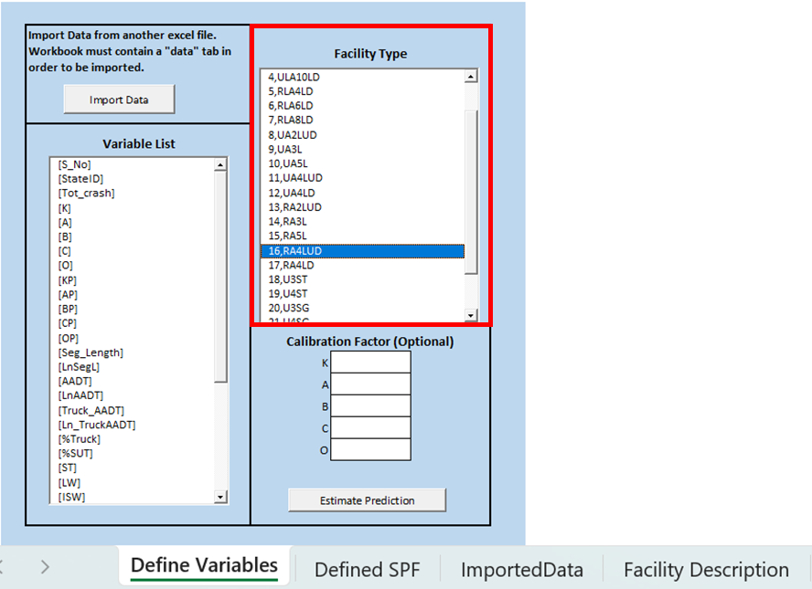

**Figure 2.7 Facility Selection (Spreadsheet Tool without Calibration)**

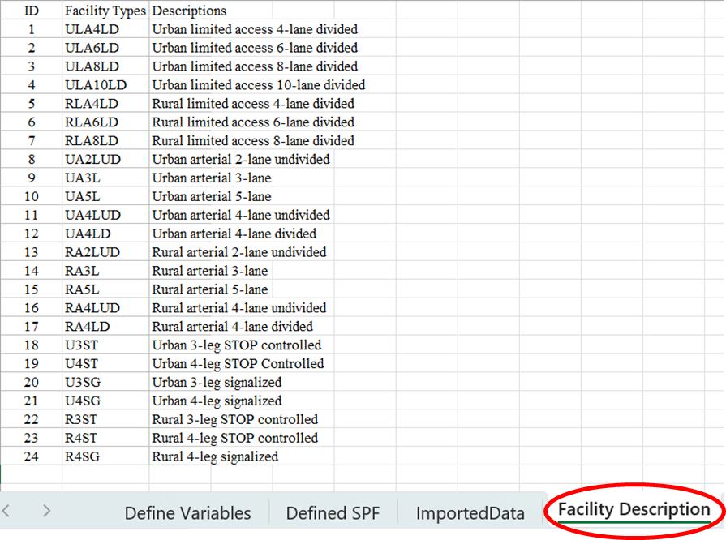

**Figure 2.8 Facility Description (Spreadsheet Tool without Calibration)**

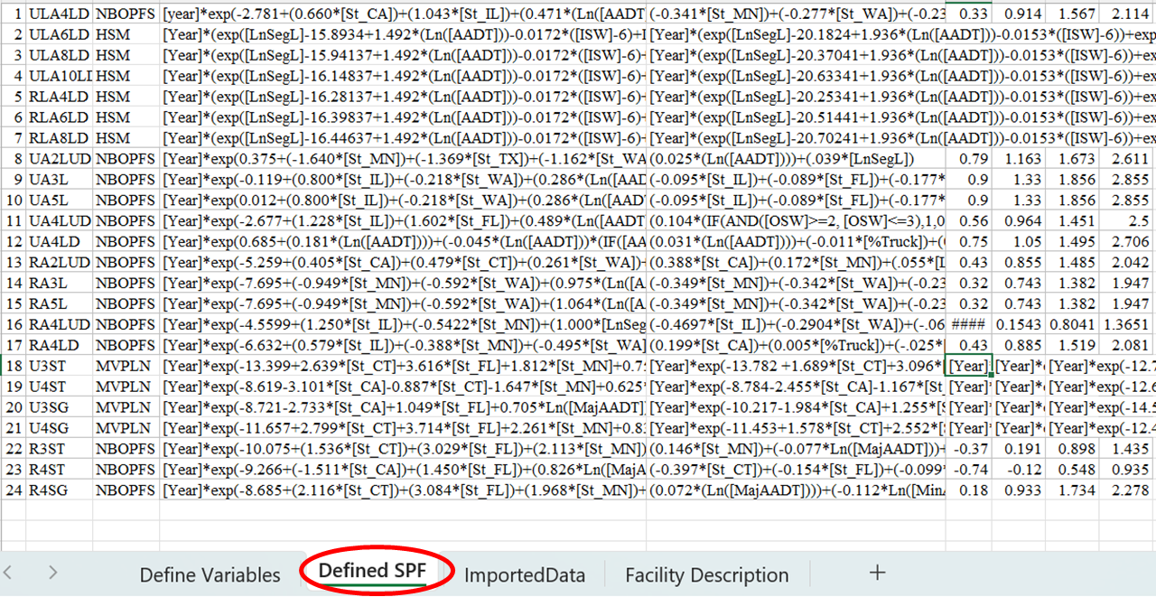

**Figure 2.9 Defined SPF Tab (Spreadsheet Tool without Calibration)**

## Estimation of Prediction

The users can estimate prediction by clicking on the “Estimate Prediction” from the “Define Variable” tab (Figure 2.10). This tool also allows the users to generate predictions with user-defined calibration factors (Figure 2.11). The users should note that these calibration factors are optional and when no factors are inserted, the tool will consider the factors as 1 for all crash severity categories.

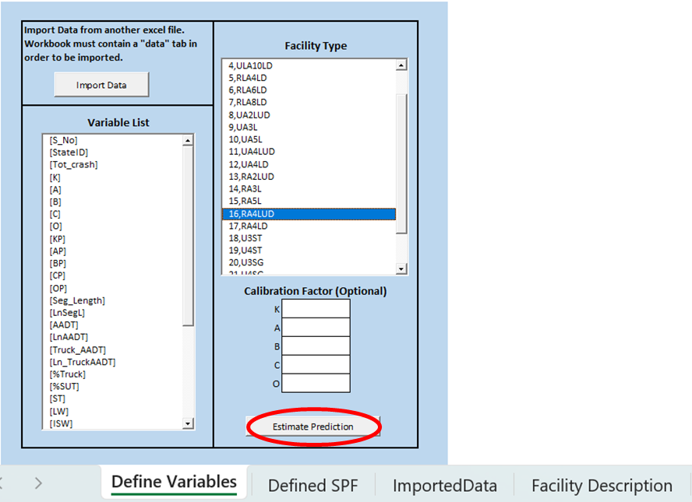

**Figure 2.10 Estimating Prediction (Spreadsheet Tool without Calibration)**

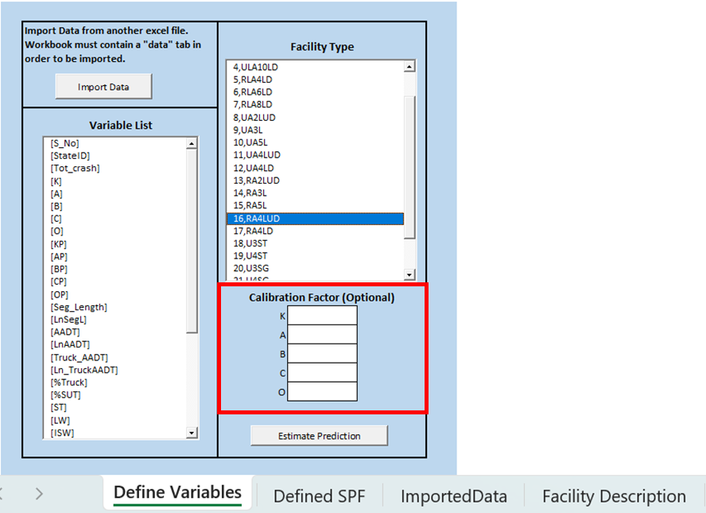

**Figure 2.11 Options to Use User-Defined Calibration Factors (Spreadsheet Tool without Calibration)**

Once the users click on the “Estimate Prediction”, the predictions for RA4LUD segments facility will be generated in the last column panels of the “ImportedData” tab (Figure 2.12).

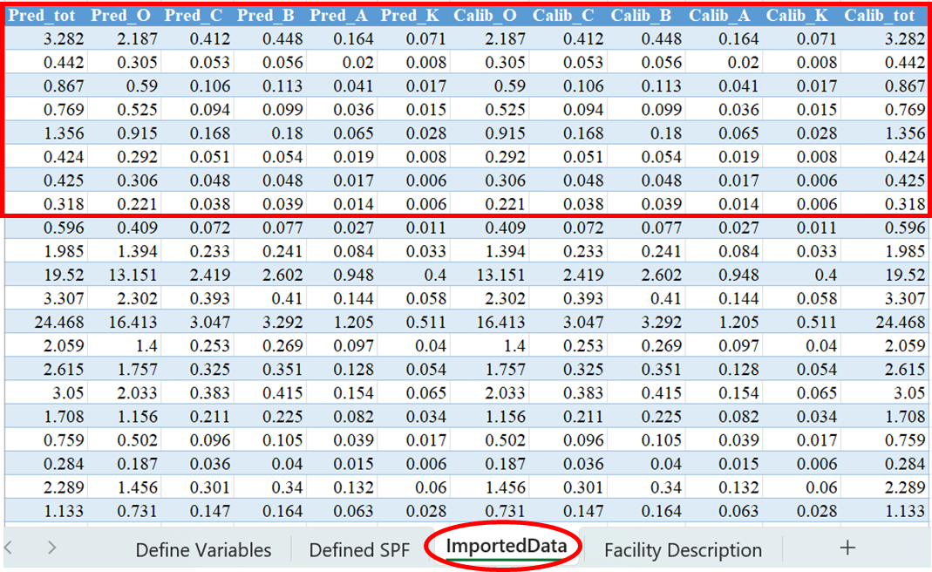

**Figure 2.12 Estimated Prediction Results of RA4LUD Facility (Spreadsheet Tool without Calibration)**

# 22-49 SPREADSHEET TOOL WITH CALIBRATION

The excel spreadsheet tool “22_49 Spreadsheet Tool with Calibration” developed in this project offers the users an interface to generate calibrated crash predictions for different facilities based on the safety performance functions developed in this project. The tool allows practitioners to import the data for the desired facilities (segments and intersections), obtain crash predictions, calibrated predictions, corresponding calibration factors and cure plots for the facility. Detailed guidance to use this calibration tool is presented in the next sections.

## Opening the Tool

The users can simply open “22_49 Spreadsheet Tool with Calibration” as any other excel file for the analysis. For unblocking and enabling content issue, the users are referred to see Section 2.1.1 of this document.

After enabling the content, the users should be able to use the tool. This calibration tool has six tabs: Define Variables, Defined SPF, Imported Data, Calibration Factors, Cure Plots and Facility Description. In the next section, we will demonstrate the use of all tabs with an example dataset of Rural arterial 4-lane undivided (RA4LUD) segments facility.

## Import Data

The users need to import data from another excel file for the analysis of a facility by using “Import Data” from the “Define Variables” tab of the tool (Figure 3.1).

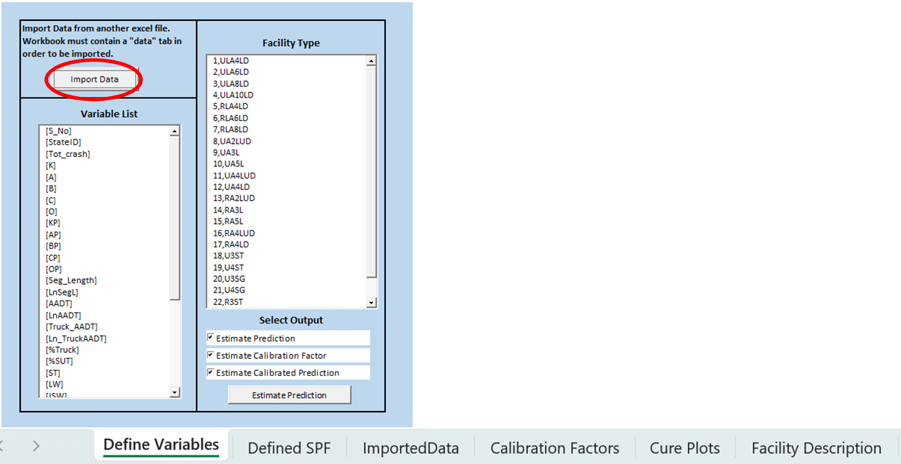

**Figure 3.1 Data Import (Spreadsheet Tool with Calibration)**

The user will note that the input excel workbook must contain a “data” tab to be imported in the tool. For example, to import the dataset of RA4LUD facility, the user should have an excel data file of RA4LUD and the excel workbook of the file must contain "data" tab to be imported (Figure 3.2). For preparation of the excel workbook file, the users are referred to section 2.1.2.1 of this document.

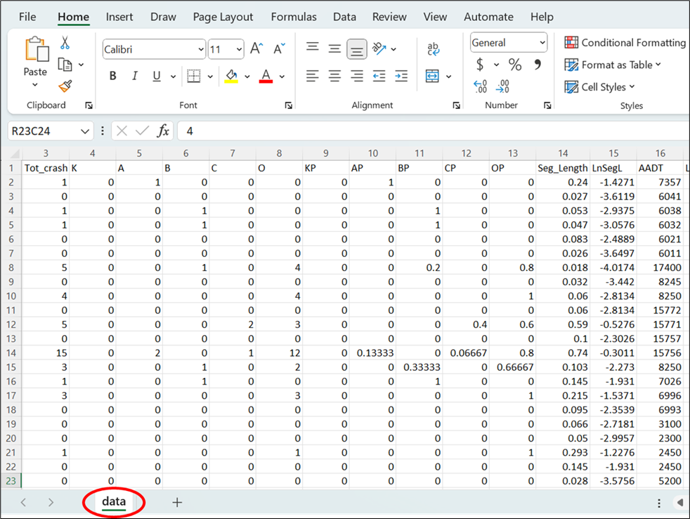

**Figure 3.2 Workbook for RA4LUD Facility with “data” Tab (Spreadsheet Tool with Calibration)**

After importing the data successfully, the users will be able to see the variable names in the “Variable List” view of the “Define Variables” tab (Figure 3.3) and the data in the “ImportedData” tab of the tool (Figure 3.4).

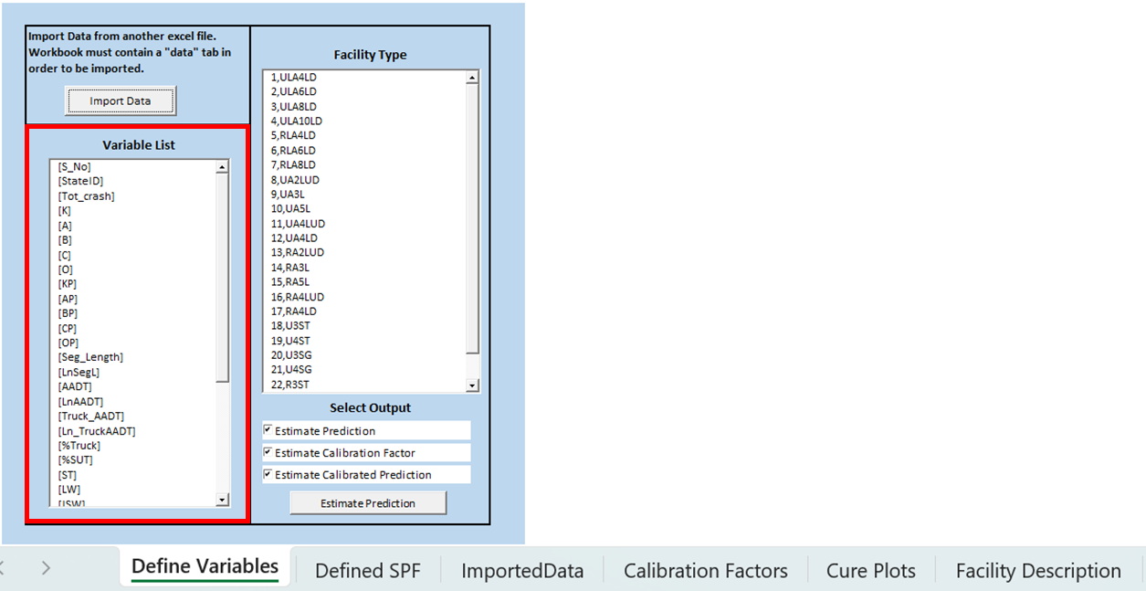

**Figure 3.3 Variable List (Spreadsheet Tool with Calibration)**

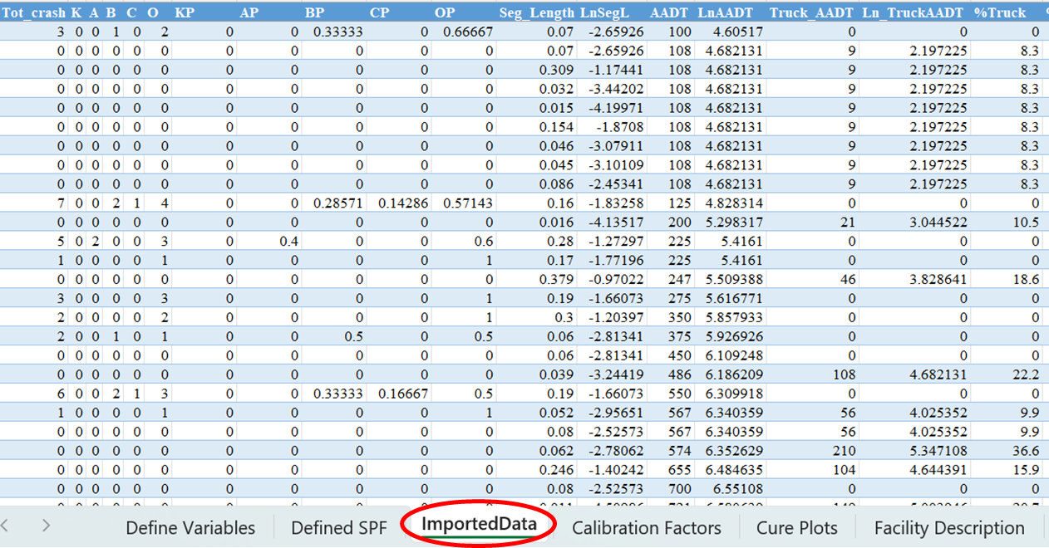

**Figure 3.4 ImportedData Tab (Spreadsheet Tool with Calibration)**

## Selection of Facility

The “Facility Type” view in the “Define Variables” tab shows the list of facilities for which models have been developed in this project (Figure 3.5). The users will need to select the facility type (for this example, RA4LUD) from this list. The users should note that the description of the facility types can be found in the “Facility Description” Tab (Figure 3.6). As mentioned earlier, this project developed SPFs for 24 facilities. The SPFs for the facility types are defined in the “Defined SPF” tab (Figure 3.7).

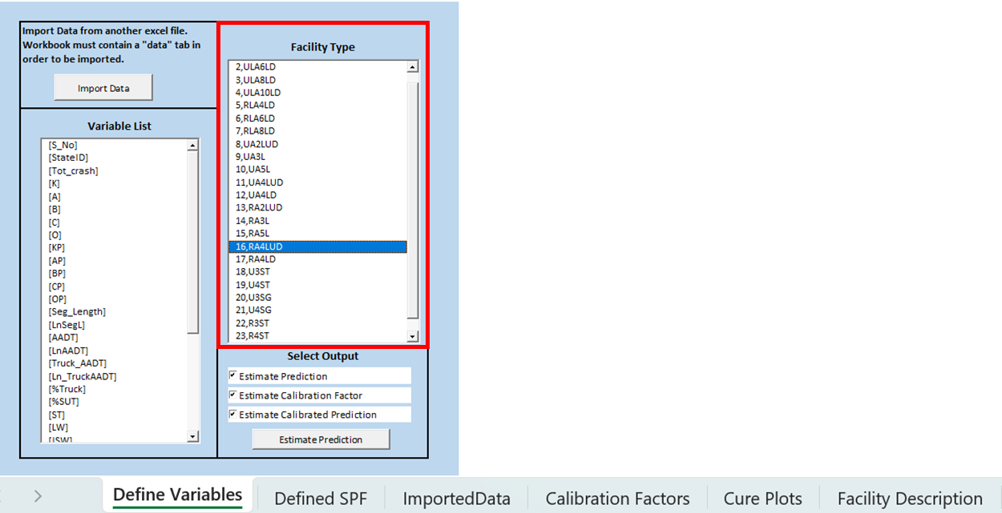

**Figure 3.5 Facility Selection (Spreadsheet Tool with Calibration)**

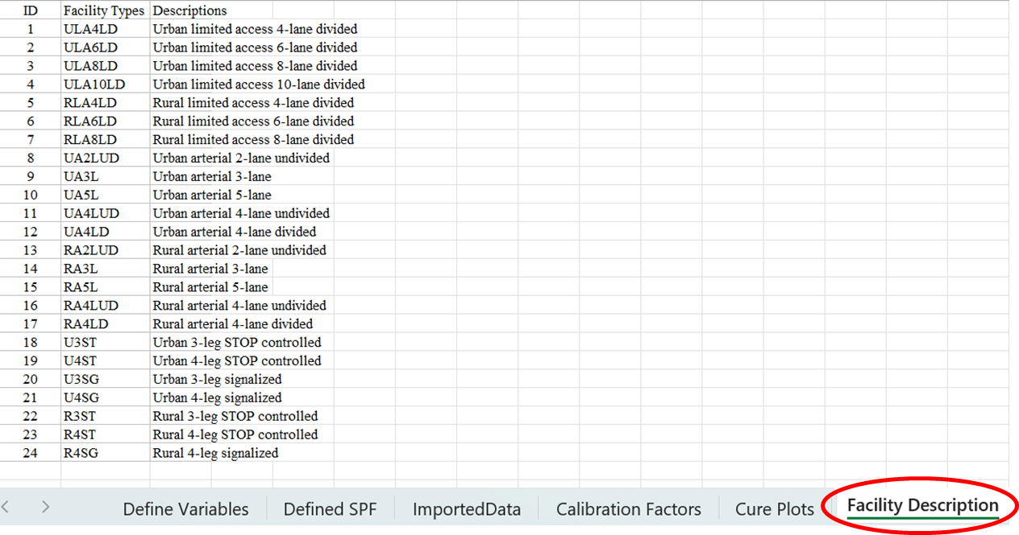

**Figure 3.6 Facility Description (Spreadsheet Tool with Calibration)**

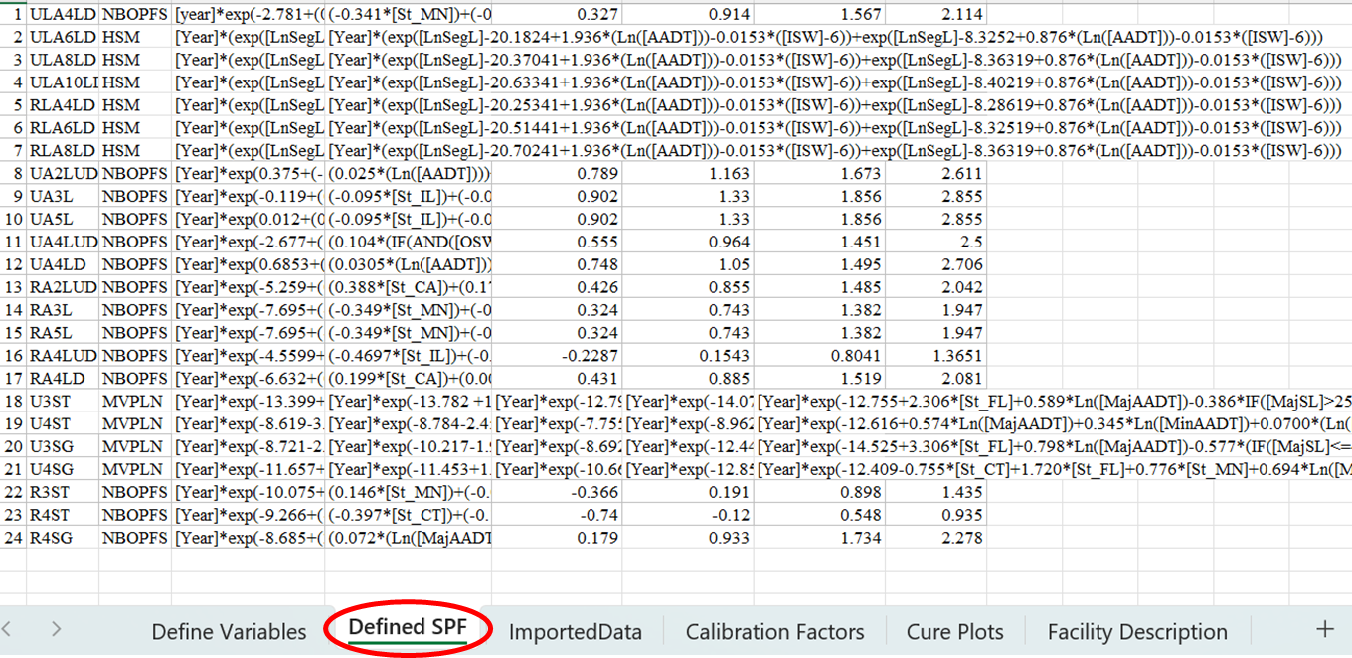

**Figure 3.7 Defined SPF Tab (Spreadsheet Tool with Calibration)**

## Estimation of Prediction

The users can estimate prediction with or without considering the calibration by selecting “Estimate Prediction” and “Estimate Calibrated Prediction”, respectively from the “Select Output” of the “Define Variables” tab (Figure 3.8). For analyzing a facility of the same jurisdictions for which SPFs have been developed, the users can estimate prediction by selecting “Estimate Prediction”. The estimated prediction will be generated in the “ImportedData” tab (Figure 3.9).

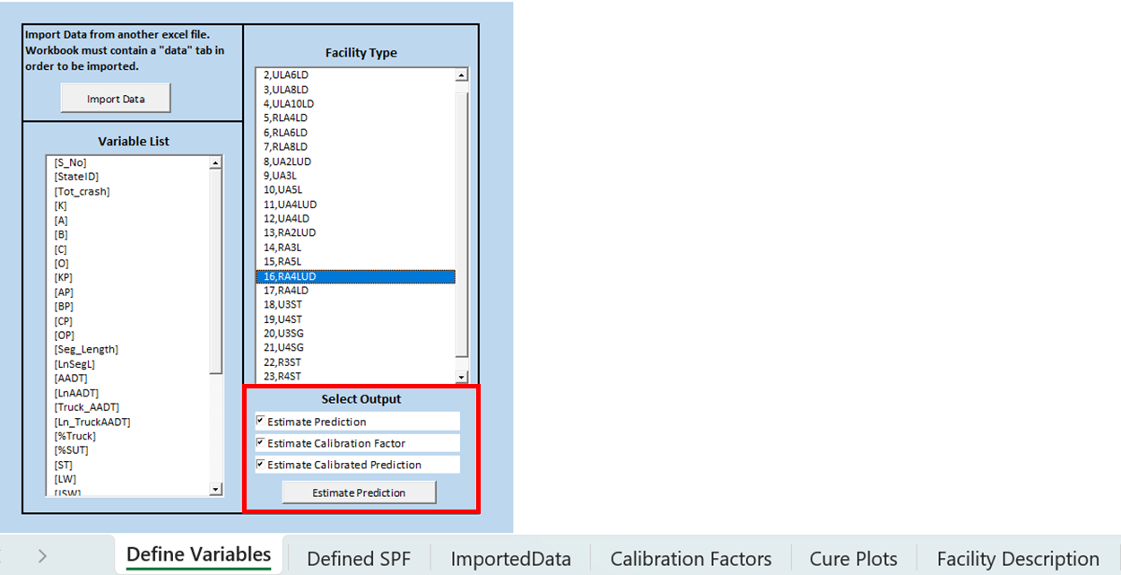

**Figure 3.8 Selection of Output (Spreadsheet Tool with Calibration)**

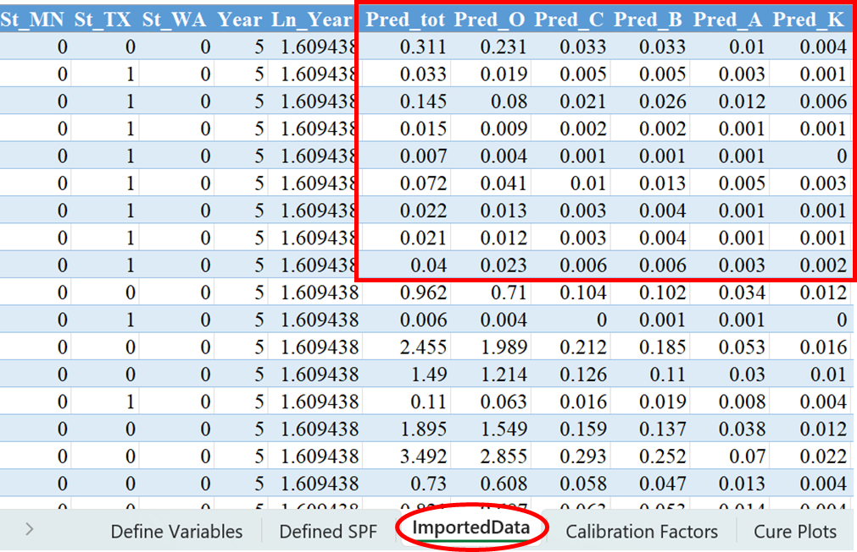

**Figure 3.9 Estimated Prediction Results of RA4LUD Facility (Spreadsheet Tool with Calibration)**

## Calibration

Calibration factors are applied in crash frequency and severity analysis when the data employed for model estimation differs with data being used for prediction in time period or geographical region. In the tool, calibration factors will be calculated and included in the prediction if users select the “Estimate Calibrated Prediction” option. The calibrated prediction values will be generated in the “ImportedData” tab. Figure 3.10 shows the estimated prediction with calibration for RA4LUD facility. If for some reason, users decide not to use the calibration factors, they may refer to the “Estimate prediction” option described in previous section. For the estimation with calibration, the “Define Variables” tab also provides the option to select the calibration factors by selecting “Estimate Calibration Factor”. The factors will be shown in the “Calibration Factors” tab of the tool (Figure 3.11).

The following procedures are employed for calculating the calibrations factors:

* Calibration is undertaken based on frequency by injury severity level.
* A threshold of a minimum of 30 crashes is used for determining whether there are sufficient data for calculating calibration factors:
  + If at least 30 crashes are observed for each severity level, then five individual calibration factors (five severity levels) are calculated. Additionally, a calibration factor for total crashes is also calculated and added in the output for interested users.
  + If fewer than 30 crashes are observed for O crashes, a single KABCO calibration factor is calculated, and the same factor is applied to each of the five severity levels. In the tool, the user will see the same calibration factor for the five severity levels.
  + If at least 30 crashes are observed for O crashes but fewer than 30 crashes are observed for C crashes, then a calibration factor for O and a calibration factor for KABC is calculated. Here the user will see one calibration factor for O crashes and the same calibration factor for other four severity levels (KABC). Additionally, a calibration factor for total crashes is also included.
  + If at least 30 crashes are observed for O and C crashes separately but fewer than 30 crashes are observed for B crashes, then a calibration factor for O, a calibration factor for C and a calibration factor for KAB is calculated. Here the user will see one calibration factor for O crashes, one calibration factor for C crashes and the same calibration factor for the other three severity levels (KAB). Additionally, a calibration factor for total crashes is also included.
  + If at least 30 crashes are observed for O, C and B crashes separately but fewer than 30 crashes are observed for A crashes, then a calibration factor for O, a calibration factor for C, a calibration factor for B and a calibration factor for KA is calculated. Here the user will see one calibration factor for O crashes, one calibration factor for C crashes, one calibration factor for B crashes and same calibration factor for the other two severity levels (KA). Additionally, a calibration factor for total crashes is also included.

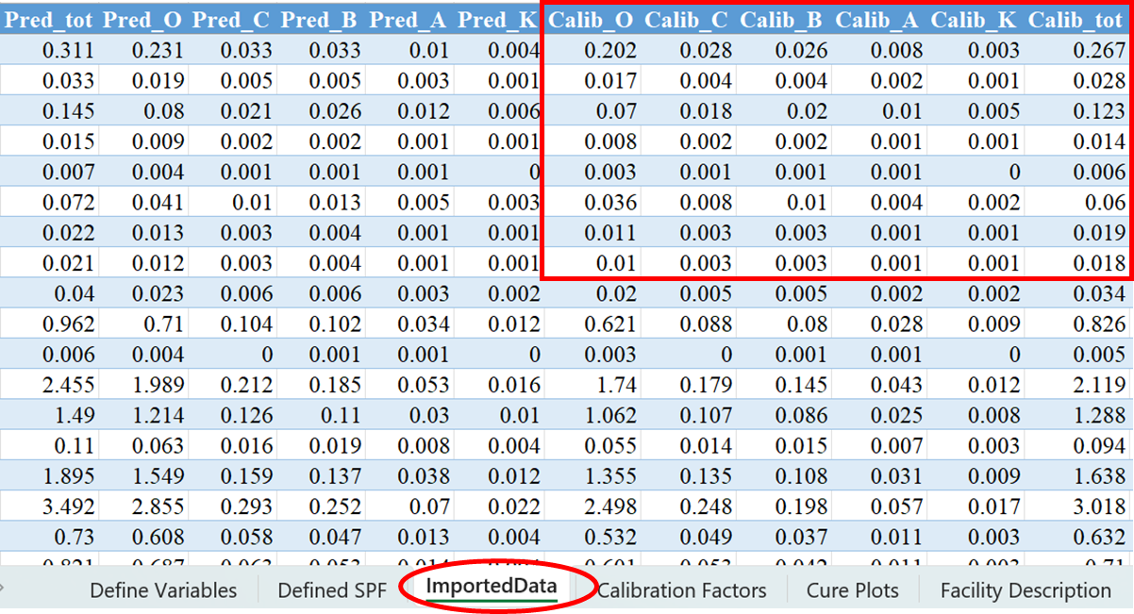

**Figure 3.10 Estimated Calibrated Prediction Results of RA4LUD Facility**

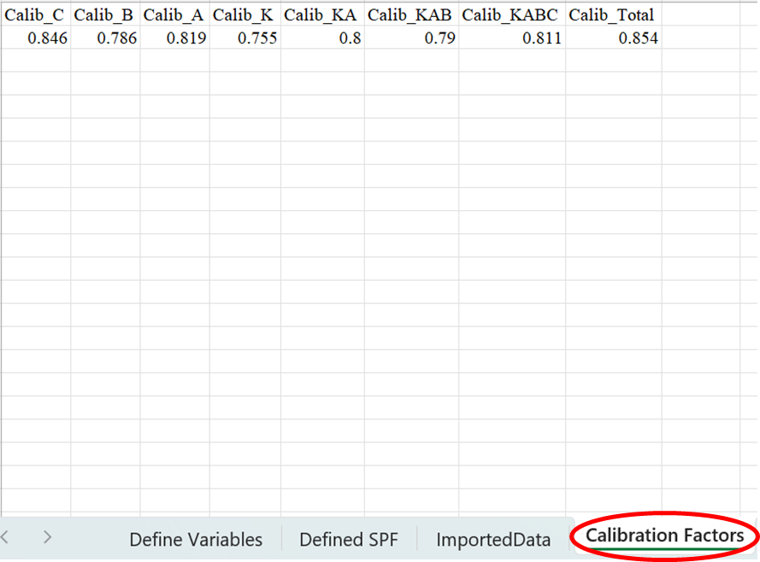

**Figure 3.11 Calibration Factors for RA4LUD Facility**

## Development of Cure Plot

The tool will generate the cure plots for AADT of segment facilities and Major AADT and Minor AADT of intersection facilities. The developed cure plots will be shown in the “Cure Plots” tab (Figure 3.12).

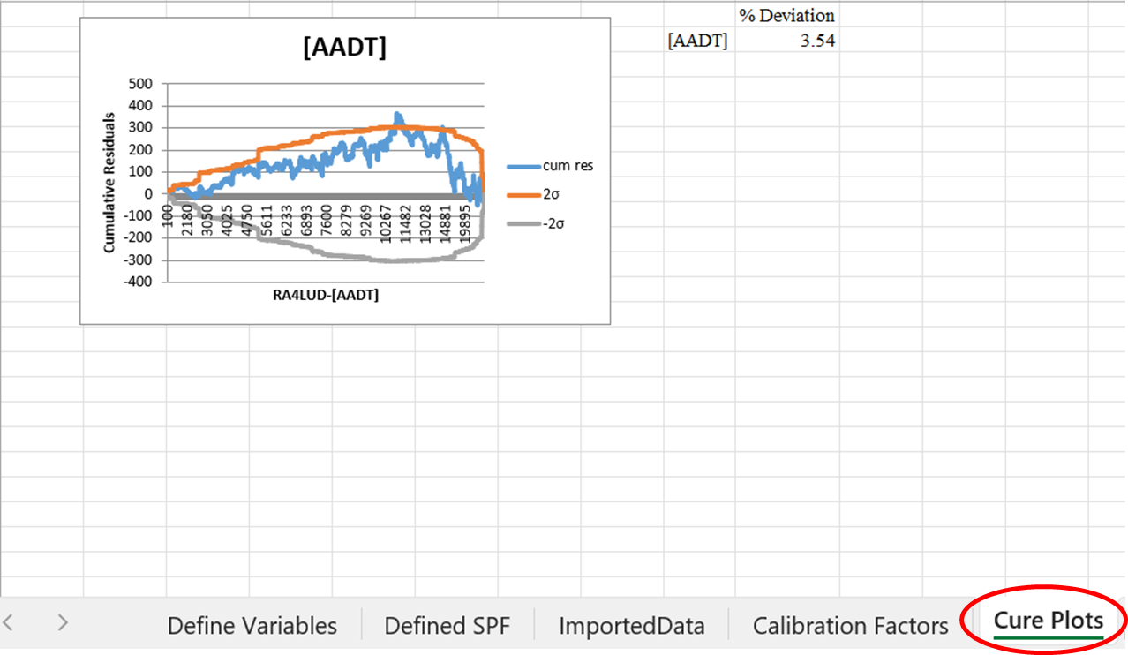

**Figure 3.12 Cure Plots Tab**

The cure plots will show the cumulative residual, confidence limits of the cumulative residuals and percentage of deviation from the confidence limits. The residuals, cumulative residuals and confidence limits are shown in the last columns of the “ImportedData” tab (Figure 3.13). The users would note that cumulative residuals outside the confidence limits indicate a poor fit over that range in the variable of interest. The upper threshold for the percent of cumulative residuals exceeding the 95 percent confidence limits is 5%. A possible option to reduce the error is to consider separate analysis for the exceeding ranges of the variable of interest. The reader would note that the percentage of residuals exceeding the 95 percent confidence limits is always lower for our selected models relative to the HSM models.

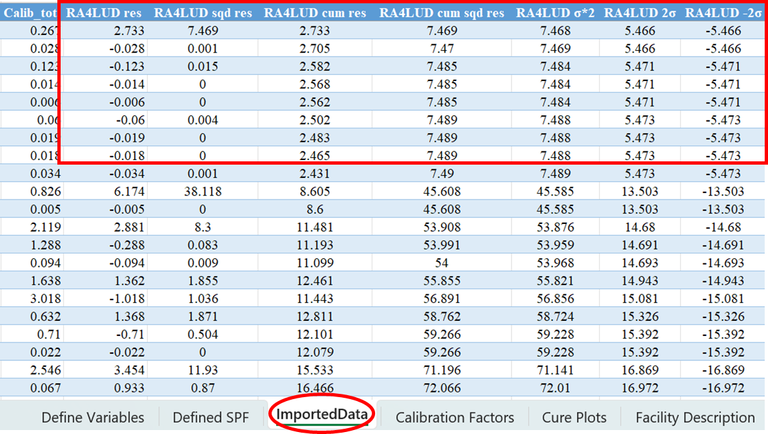

**Figure 3.13 Residuals and Confidence Limits of the Cure Plots for RA4LUD Facility**

# 22-49 DATA INPUT AND PREDICTION TOOL

The “22_49 Data Input and Prediction Tool” developed in this project will allow users to create datasets for the facilities (segments or intersections) by inputting roadway and intersection information. This tool also allows the users to generate predictions with or without calibration for the 24 facilities assessed in this project. For the calibrated predictions, the users are required to input calibration factors. These calibration factors can be obtained from the “22_49 Spreadsheet Tool with Calibration” for the corresponding facilities. Detailed procedures to use the tool are discussed in the following sections:

## Opening the Tool

The users can simply open “22_49 Data Input and Prediction Tool” as any other excel file for use. For unblocking and enabling content issue, the users are referred to see Section 2.1.1.

The tool has 4 tabs: Segment Input, Segment Output, Intersection Input and Intersection Output. Segment Input and Segment Input tabs are used for segment facilities while the Intersection Input and Intersection Output tabs are used for intersection facilities.

## Segment Data Input and Prediction

The users can insert segment information by using “Segment Input” tab of the tool (Figure 4.1). Before the data input, the users need to select the facility type (from drop-down menu) for which predictions will be generated (Figure 4.2). This menu shows the list of 17 segment facilities for which SPFs have been developed in this project. The Segment Input tab offers the flexibility to input segment information such as segment ID, location (state) of segment (with drop-down menu), length of segment, AADT, % total truck traffic, % single unit truck traffic, lane width, shoulder width, shoulder type (paved or unpaved from drop-down menu), median width, speed limit and can indicate whether the segment is located in a high truck zone or not (with drop-down menu) (Figure 4.1). This interface also provides the option to input crash information and calibration factors. In this tool, the “Average Crash Counts” information is only needed for Urban Limited Access 6-Lane, 8-Lane, 10-Lane and Rural Limited Access 4-Lane, 6-Lane and 8-Lane Divided segment facilities. This is because the “Average Crash Counts” information is needed for the facilities that use HSM model for crash predictions. The HSM model equations provide the predictions for Fatal-Injury crashes (KABC) and property damage crashes (O) separately. To get the predictions separately for K, A, B and C, we need the proportion of these crash categories in the KABC crashes. We can obtain these proportions from observed crashes. The users can input average crash counts of K, A, B, C and PDO over 2, 3, 4 or 5-year observed period. For the calibration factors information, if the users do not insert the values for calibration factors, the tool will automatically consider the values as one. This tab also guides the users with a few important comments regarding the use of the tool.

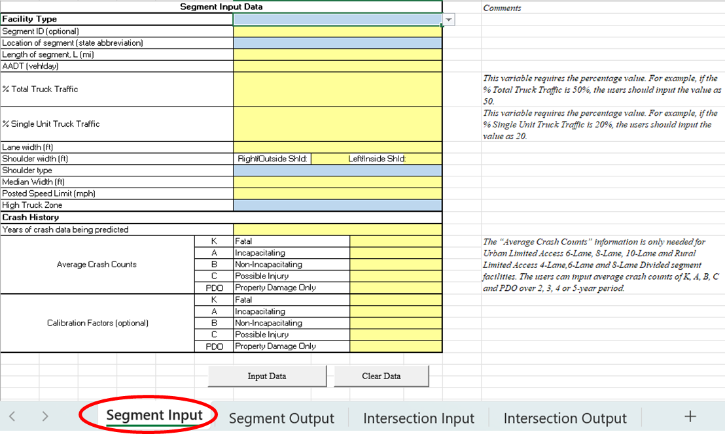

**Figure 4.1 “Segment Input” Tab**

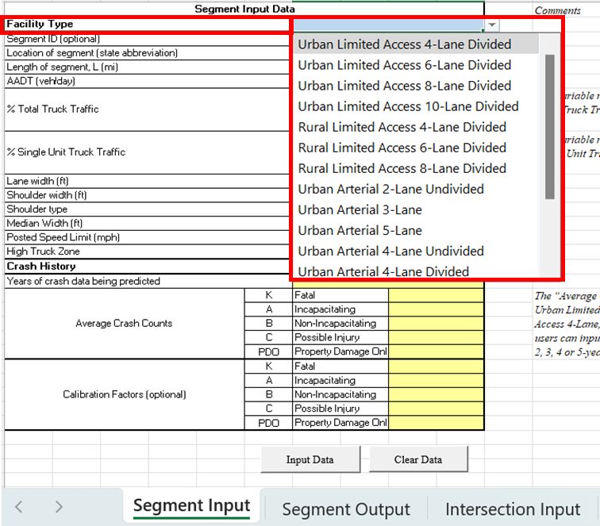

**Figure 4.2 Selection of Segment Facility Type**

After adding all the information and selecting facility type, users can generate the dataset including predictions with and without calibration by clicking on the “Input Data” from the Segment Input tab (Figure 4.3). The users should note that the values of AADT and speed limit should be positive integers. In addition, any variable values outside the ranges for the respective facilities will show error messages (Figure 4.4). The users can re-input the correct values as instructed by the error messages. The dataset and the predictions will be generated in the “Segment Output” tab (Figure 4.5 and Figure 4.6). It is to be noted that the users can generate predictions for multiple segments by defining Segment ID 1,2,3….

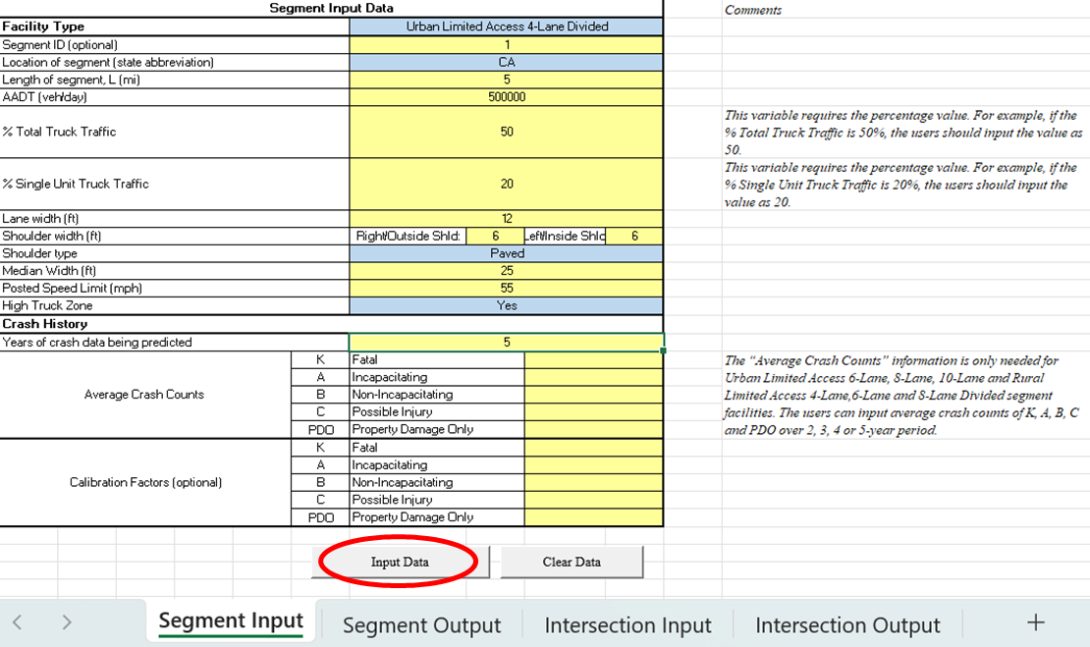

**Figure 4.3 Generating Segment Dataset and Prediction**

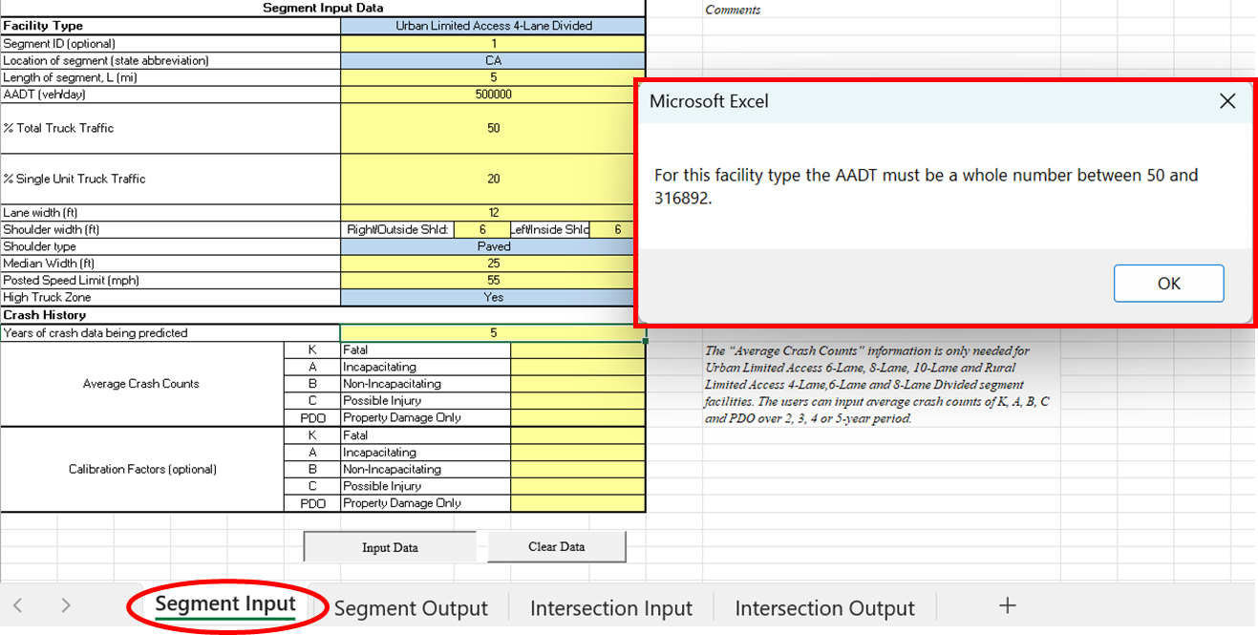

**Figure 4.4 Segment Data Input Error**

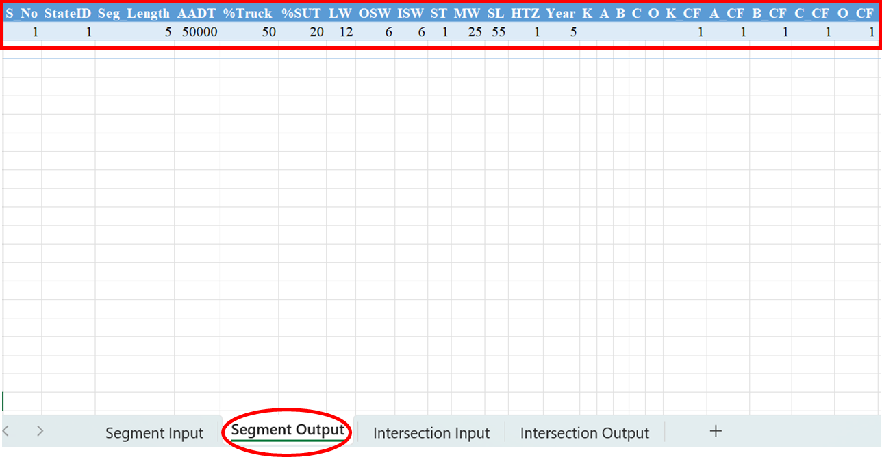

**Figure 4.5 “Segment Output” Tab Showing Input Data**

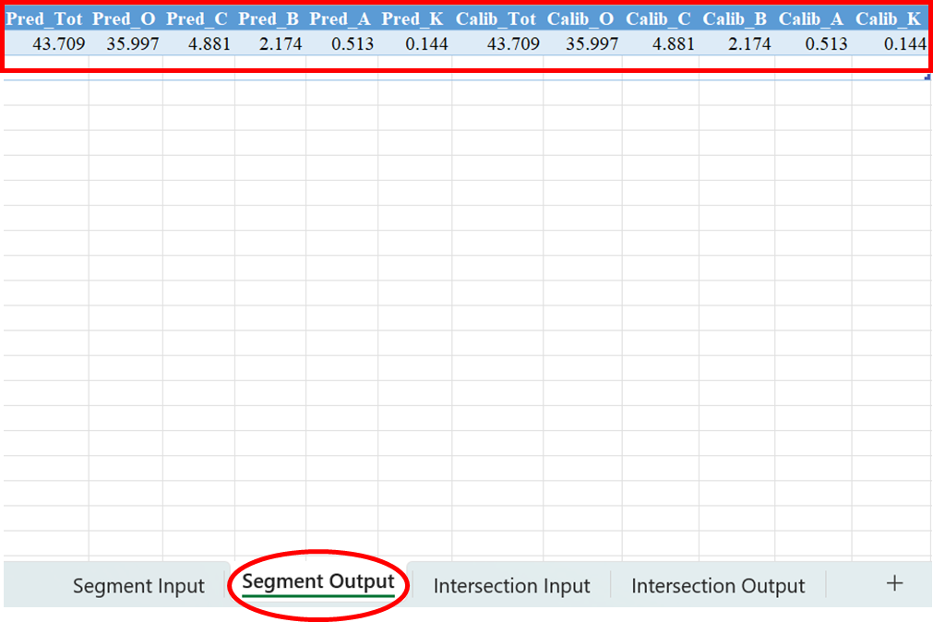

**Figure 4.6 “Segment Output” Tab Showing Predictions**

The users can clear the outputs by clicking “Clear Data” and can use the tool for a new segment (see Figure 4.7).

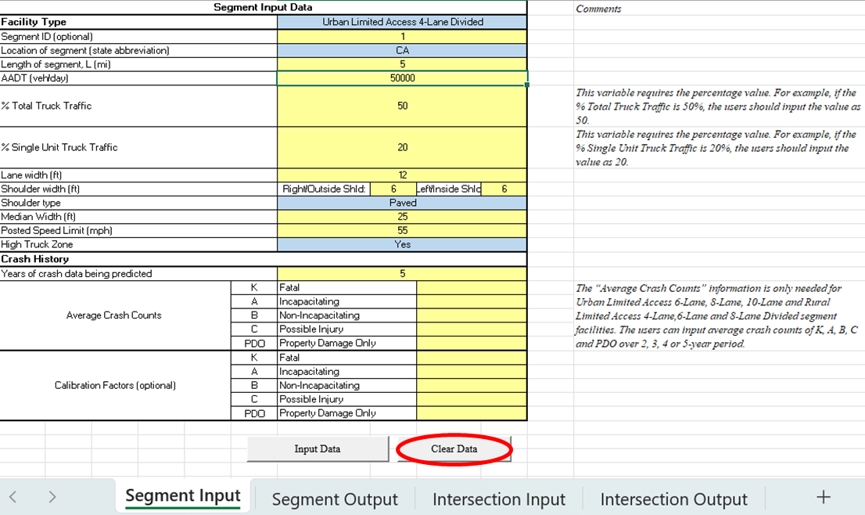

**Figure 4.7 Clearing the Segment Output**

## Intersection Data Input and Prediction

The users can insert the information for an intersection by using “Intersection Input” tab of the tool (Figure 4.8). Before the data input, the users need to select the facility type (from drop-down menu) for which prediction will be generated (Figure 4.9). This menu shows the list of 7 intersection facilities for which SPFs have been developed in this project. This interface also offers the flexibility to input intersection information such as intersection ID, location (state) of intersection (with drop-down menu), AADT, % total truck traffic and number of lanes in both major and minor roads, lighting information (with drop-down menu), major road speed limit and can indicate whether the intersection is located in a high truck zone or not (by using the drop-down menu) (Figure 4.8). This interface provides the option to input calibration factors. For calibration factors, if the users do not insert the values for calibration factors, the tool will automatically consider the values as one. This tab also guides the users with a few important comments regarding the use of the tool.

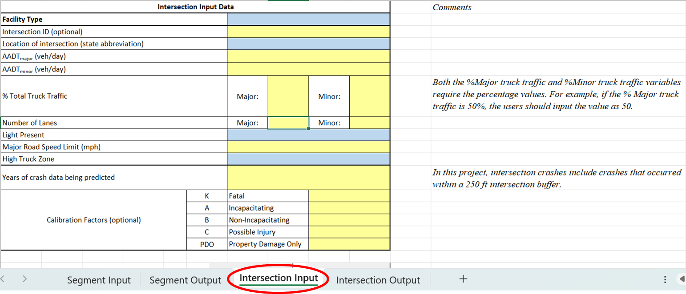

**Figure 4.8 “Intersection Input” Tab**

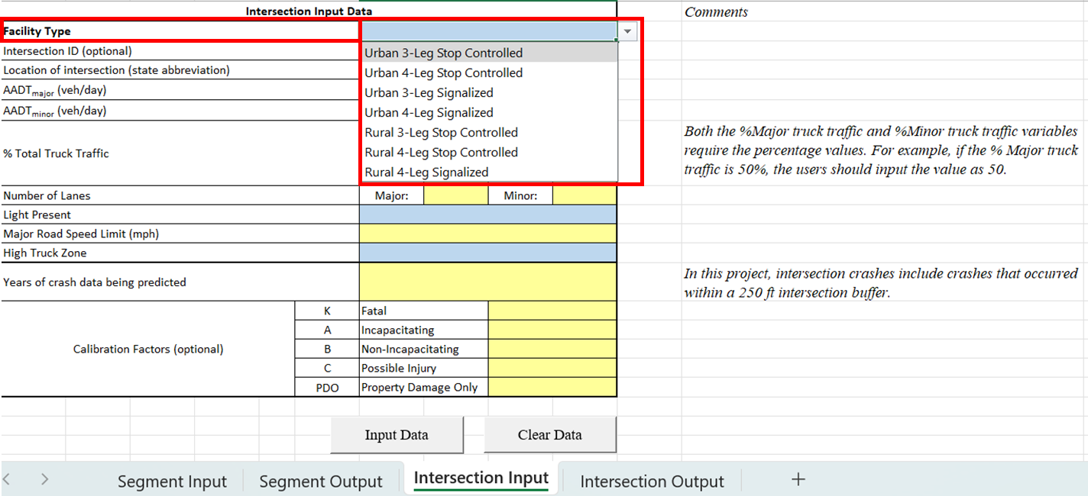

**Figure 4.9 Selection of Intersection Facility Type**

After adding all the information and selecting facility type, the users can generate the dataset including predictions with and without calibration over an expected period by clicking on the “Input Data” from the Intersection Input tab (Figure 4.10). The users should note that, in this project, intersection crashes include crashes that occurred within a 250 ft intersection buffer.

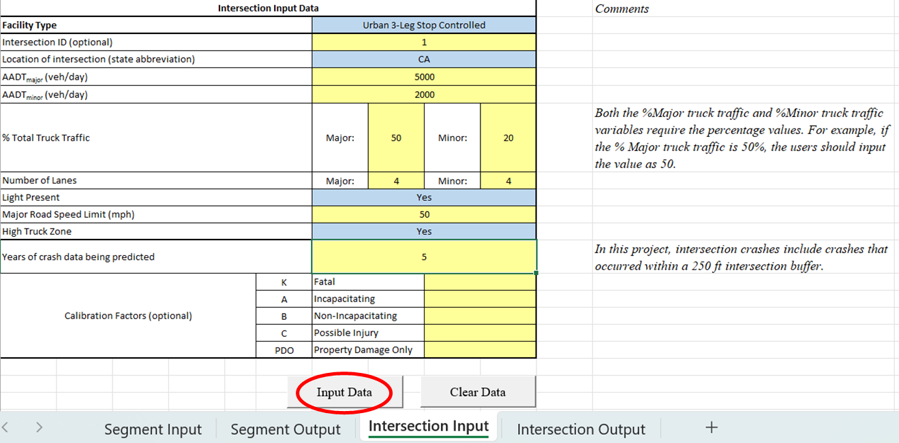

**Figure 4.10 Generating Intersection Dataset and Prediction**

The users should also note that the values of AADT and speed limit should be integers. In addition, any variable values outside the ranges of respective facilities will show error messages. The users can re-input the correct values as instructed by the error messages (Figure 4.11).

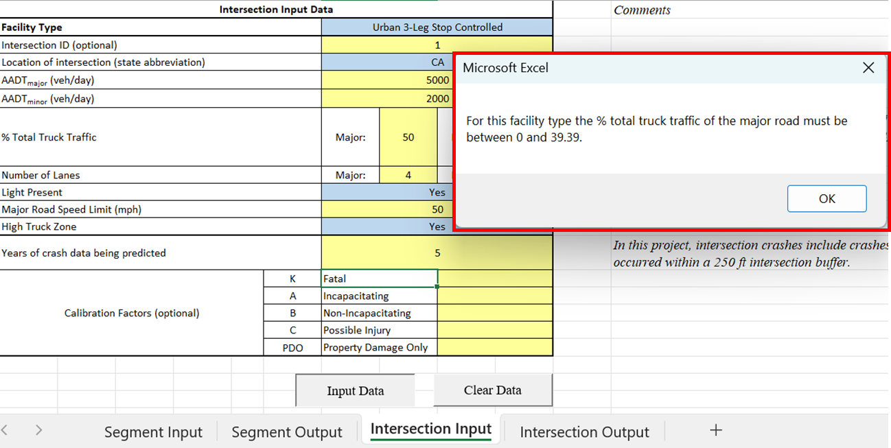

**Figure 4.11 Intersection Data Input Error**

With the corrected values, the dataset and the predictions will be generated in the “Intersection Output” tab (Figure 4.12 and Figure 4.13). It is to be noted that the users can generate predictions for multiple intersections by defining Intersection ID 1,2,3…. The users can clear the outputs by clicking “Clear Data” and can use the tool for a new intersection (see Figure 4.14).

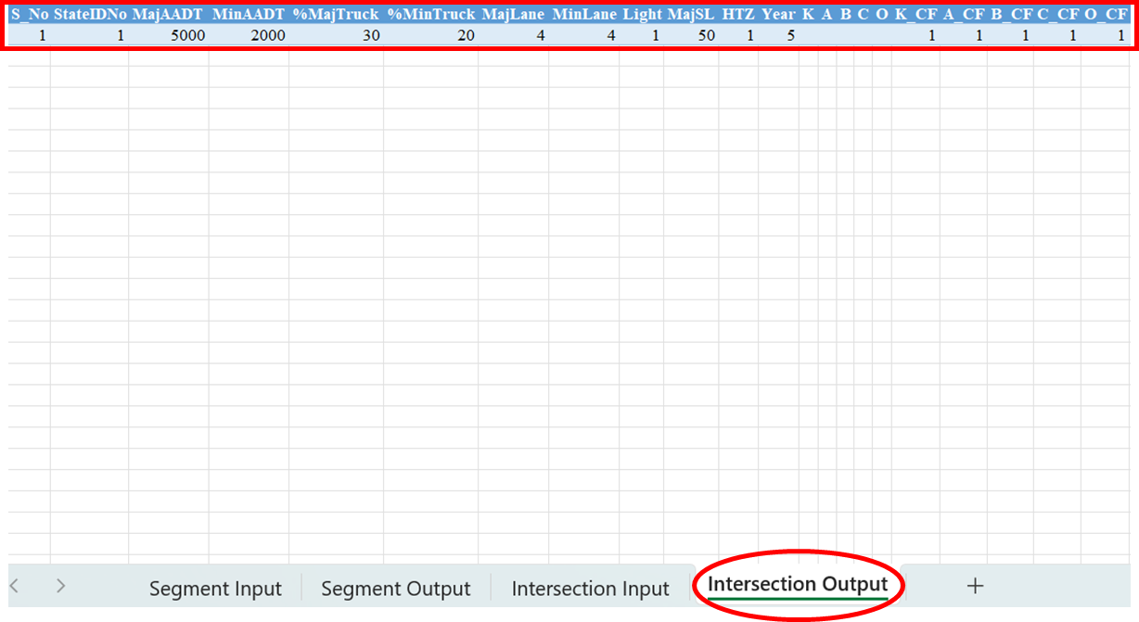

**Figure 4.12 “Intersection Output” Tab Showing Data**

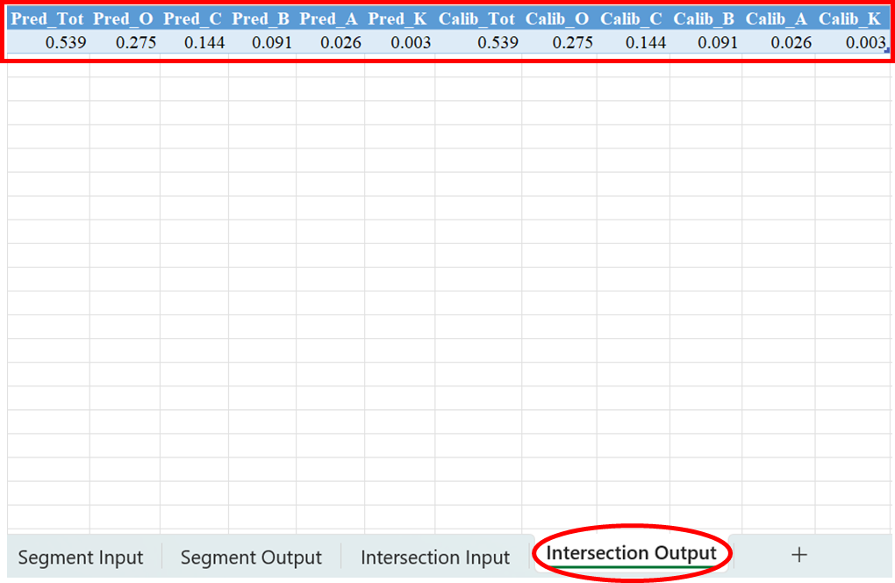

**Figure 4.13 “Intersection Output” Tab Showing Predictions**

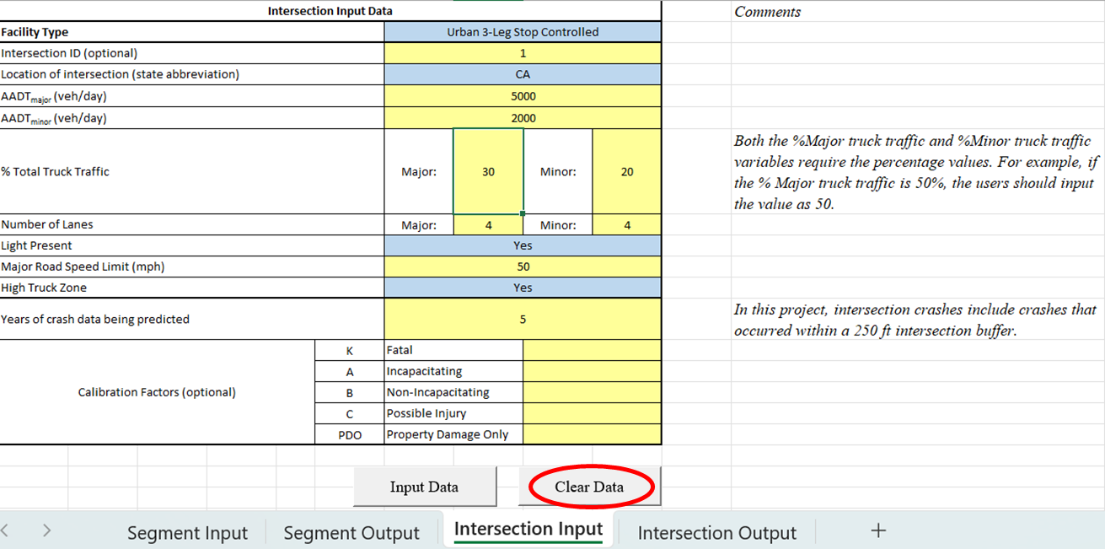

**Figure 4.14 Clearing the Intersection Input Data**